中科院城市环境研究所
2024-2025学年研究生等级奖学金/年度考核申请表

研究生姓名 | Alexis Kayiranga | 学号 | 2021A8018137005 | 导师姓名 | SUN XIN
学科专业 | Soil Urban Ecology Research group | 入学时间 | 2021 | 学生手机号 | 13005141431
是否申请等级奖学金 |  | Yes
已发表的论文或申请的专利（包括：所有作者名、论文题目、发表期刊、年、卷、期、起止页码/成果或专利名称和专利号、出版社或授权单位、时间。在研究生名字下划横线，在导师名字上打“*”号）：

1) Kayiranga, A., A. Isabwe, H. Yao, H. Shangguan, J. L. K. Coulibaly, M. Breed, and X. Sun*. 2024. Distribution patterns of soil bacteria, fungi, and protists emerge from distinct assembly processes across sub communities. Ecology and Evolution 14 (2024) e11672: https://doi.org/10.1002/ece3.11672.
2) Kayiranga, A., Z. Li, A. Isabwe, X. Ke, C. H. Simbi, B. E. Ifon, H. Yao, B. Wang, and X. Sun*. 2023. The Effects of Heavy Metal Pollution on Collembola in Urban Soils and Associated Recovery Using Biochar Remediation: A Review. Int J Environ Res Public Health 20. https://doi.org/10.3390/ijerph20043077.
3) Kayiranga, A., Z. Luo*, J. C. Ndayishimiye, F. Nkinahamira, E. Cyubahiro, T. Habumugisha, C. Yan, J. Guo, Z. Zhen, A. Tuyishimire, and H. D. Izabayo. 2021. Insights into thallium adsorption onto the soil, bamboo-derived biochar, and biochar amended soil in Pomelo orchard. Biochar 3:315-328. https://doi.org/10.1007/s42773-021-00095-1.
4) Zhuanxi L*., Kayiranga, A., Ernest U., Qinghua Z., Changzhou Y., Jianhua G., Baoshan X 2020. Thallium contamination in agricultural soils and associated potential remediation via biochar utilization: Biochar, Vol 2:33–46: https://doi.org/10.1007/s42773-020-00042-6.

5) Coulibaly, J. L. K., X. Gong, Y. Shao, H. Shangguan, Kayiranga, A, I. Koné, Y. Cai, and X. Sun*. 2025. Urban greenspaces reduce the community specialization of soil nematodes. Geoderma. 453 (2025) 117139: DOI:10.1016/j.geoderma.2024.117139.
6) Gasana Zachee, Kayiranga A, Jean Claude Nizeyimana; Shaohua Tian; Justin Rugema; Lelan You; Xu Huang*; Jian-Qiang Su. Removal of antibiotics and antibiotic resistance genes using microalgae-based wastewater treatment system: a bibliometric review and mechanism analysis. Journal of Water Process Engineering 72 (2025) 107496: https://doi.org/10.1016/j.jwpe.2025.107496.
7) Cyubahiro, E., Z. Luo*, Kayiranga, A, T. Habumugisha, F. Nkinahamira, J. C. Ndayishimiye, C. Yan, J. Guo, and Z. Wang. 2022. Thallium removal by the montmorillonite biochar composite: insights and environmental implications. Desalination and Water Treatment 253:177-193. doi: 10.5004/dwt.2022.28301.
8) Habumugisha, T., Z. Zhang, J. C. Ndayishimiye, F. Nkinahamira, Kayiranga, A, E. Cyubahiro, A. Rehman, C. Yan, and X. Zhang*. 2022. Evaluation and optimization of the influence of silver cluster ions on the MALDI-TOF-MS analysis of polystyrene nanoplastic polymers. Anal Methods 14:763-772. doi:10.1039/d1ay02219a.
9) Simbi, C. H., F. Yao*, J. Zhang, D. Tenaw, J. Sugira Murekezi, M. T. Magati, H. Hirwa, A. S. Al-Sakkaf, Kayiranga, A, and J. Peng. 2024. Balancing growth and preservation: Unravelling Africa's carbon-economic nexus through the environmental kuznets curve. Journal of Heliyon: 10: e39269. https://doi.org/10.1016/j.heliyon.2024.e39269.
10) Kalisa, W., J. Zhang*, T. Igbawua, Kayiranga, A, F. Ujoh, I. S. Aondoakaa, P. Tuyishime, S. Li, C. H. Simbi, and D. Nibagwire. 2021. Spatial Multi-Criterion Decision Making (SMDM) Drought Assessment and Sustainability over East Africa from 1982 to 2015. Remote Sensing 13. https://doi.org/10.3390/rs13245067.

Manuscript in progress of submission

1) Alexis Kayiranga, Bin Wang, An Xie, Justin Louis Kafana Coulibaly, Jean Claude Ndayishimiye, Faith Ka Shun Chand, Stefan Scheu, Xin Sun. Urban flooding disrupts soil fauna communities in urban greenspaces resulting in shifts in body size distribution particularly in exotic plant communities. Submitted manuscript (in progress of submission).
2) Alexis Kayiranga, Denis Mburu Njoroge, Justin Louis Kafana Coulibaly, Bin Wang, An Xie, Hua-Yuan Shangguan, Jean Claude Ndayishimiye, Peter Rwibasira, Xin Sun. The Impact of Flooding on Terrestrial Invertebrate Communities: A Global Meta-Analysis Across Different Land Use Types and Taxa. Submitted manuscript (in progress of submission).
3) Justin Louis Kafana Coulibaly, Xin Gong, Alexis Kayiranga, Huayuan Shangguan, Yanbo Chen, Xiuling Yu, Saichao Zhang, An Xie, Taha Ahmed Mohamed, Nico Eisenhauer, Xin Sun. Nematode diversity loss and community change in urban green spaces explained by alterations in soil pore structure and chemical properties (in progress of submission).

参加公益活动情况（学生会任职，组织和参加集体活动等）：
- I attended the International Symposium on Urban Biodiversity and Sustainable Development (Asia region, 20–21 February 2025; also assisted in hosting by receiving a guest at the airport).
- International workshop on coastal and wetland ecosystems and global change organized by College of the Environment and Ecology, Xiamen University Key Laboratory of the Coastal and Wetland Ecosystems (Xiamen University), Ministry of Education, International Institute for Sustainability Science, Xiamen University Coastal and Ocean Management Institute, Xiamen University (9 November 2024, attendee).
- Urban Science and Climate Adaptation organized by Institute of Urban Environment, Chinese Academy of Sciences (24/06/2024, attendee).
- Sino-Russia International Symposium on Urban Biodiversity and Ecological Functions (11-13/06/2024, attendee).
- International conference on Many ecologists glibly designate soil as the abiotic environment of plants, a phrase that gives me the creeps (online conference, 14/10/2024, attendee).
- Soil sampling in Rwanda (2024, March).
Empowering Students Through Research: A Summer School Experience (2024).
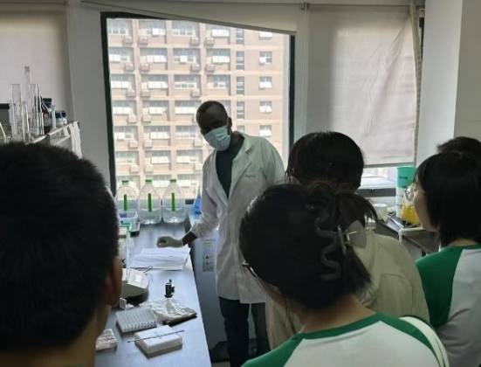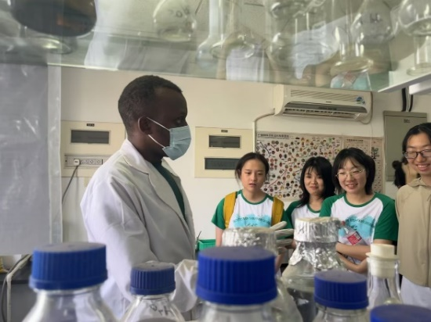
科研工作内容（研究意义、项目资助来源、主要完成的工作）：
Distribution patterns of soil bacteria, fungi, and protists emerge from distinct assembly processes across subcommunities
Our research examined microbial communities—bacteria, fungi, and protists—by classifying them into subcommunities based on abundance, revealing that conditionally rare and conditionally rare or abundant taxa dominated across all domains. Environmental factors such as pH, moisture, total phosphorus, and the carbon-nitrogen ratio were the main drivers of community composition, while rare taxa were more influenced by stochastic processes. Overall, the study underscores that microbial diversity is shaped largely by environmental filtering, especially within dominant subcommunities, while rare taxa exhibit more random distribution patterns.
Research funding Source
The above work was supported by the National Natural Science Foundation of China (32361143523), the Ningbo S&T project (2021-DST-004) and the International Partnership Program of Chinese Academy of Sciences (No. 322GJHZ2022028FN). We sincerely thank Prof. Yong-Guan Zhu for providing guidance and the platform to implement this work, and Ms. Ting Chen at Northeast Normal University for her contributions to this work.

Urban greenspaces reduce the community specialization of soil nematodes
Our research examined how urbanization and land use impact soil nematode communities, revealing that species richness and specialization were significantly lower in urban farmlands compared to natural forests. Environmental factors such as soil pH, total phosphorus, and population density were key drivers of reduced specialization, with forest soils hosting more unique specialist species, while urban areas favored generalist-dominated communities. Overall, the study shows that urbanization alters soil conditions in ways that reduce nematode diversity and specialization, emphasizing the importance of forests in conserving specialized soil biodiversity.
Research funding Source
This work was supported by the National Key Research and Development Program of China (No. 2023YFF1304600); National Natural Science Foundation of China (No. 32361143523); Ningbo S&T project (2021-DST-004); International Partnership Program of Chinese Academy of Sciences (No. 322GJHZ2022028FN).
双面打印，可另加附页

导师推荐意见 | （对该生的评价及突出特点描述，以及是否同意其申请等级奖学金）：  是否同意该生申请等级奖学金：□是；□否  导师签字  年 月 日
评审组意见 | 年度考核结果：□通过 □不通过  等级奖学金评审：□不符合申请条件  □符合申请条件，经评审，该生获得城市环境研究所 等奖学金。  评审组组长签字  年 月 日
单位意见 | 同意评审组意见。  盖 章  年 月 日
双面打印，可另加附页

